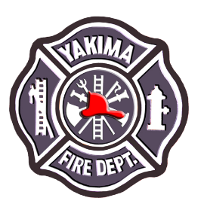 **Mobile/Event Vendors within City of Yakima**

Any and all events in public places, city owned occupancies or events open to the general public in the City of Yakima are subject to a Fire and Life Safety Inspection to ensure safety for all participants in such events. The following is a brief summary of what to expect as a vendor from these inspections.

**Tents and Coverings**

* Any temporary structure larger than 400 square feet require a permit and inspection through the City of Yakima Building Official. The Code Administration Department can be contacted at 509-575-6126.
* Tents larger than 10’X 10’ must be made of fire resistive material and must conform to labeling and certification in accordance with Sections 3104.3 and 3104.4 of the International Fire Code.
* Tents used for cooking operations of any kind must be made of fire resistive material to the standards listed above regardless of the tent size.
* Tents used for cooking operations:
  + - Cannot be open to the public.
    - Cooking appliances must be a minimum 36 inches (3 feet) away from tent walls.
    - Cooking appliances must have minimum vertical clearance of 48 inches from appliance to tent larger than 10’X10’ or 42 inches from tent 10’X10’ or smaller.
    - Must be a minimum five (5) feet away from any other tents/vendors.

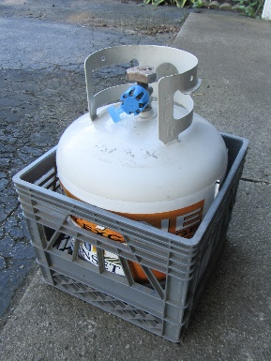**Vendors Cooking, Heating or Preparing Food**

* Tent must be made of fire resistive material (see above).
* Any compressed cylinders (propane or other compressed gas or liquid)

must be secured to prevent tipping or dislodging

* + If compressed cylinder contains flammables, it must be a safe distance away from cooking or heating appliance (minimum of 3 feet)
  + Cylinders must be in good working order free of defects, dents, marring, burn marks, etc.
  + 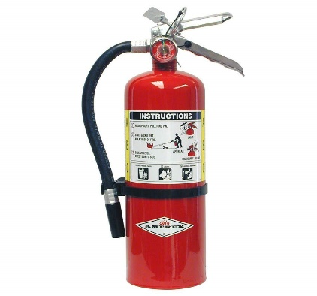Cylinders must be protected from potential contact

with vehicles

* Must have operational class ABC fire extinguisher with a

minimum rating of 2:A 10:BC. Extinguisher must be up

to date on its annual service/inspection with tag present.

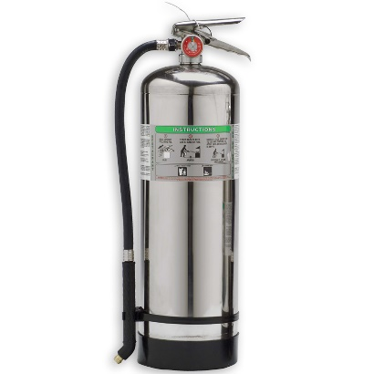

* + - Any cooking operations that create, cause or

disperse grease laden vapors must also have a

Class K fire extinguisher (frying, grilling, deep frying, etc.)

Extinguisher must be up to date on annual service/inspection with tag present.

* + - EXTINGUISHERS MUST BE READILY ACCESSIBLE AT ALL TIMES!!

(cannot be obstructed or hidden in cabinets, etc.)

**Food Trucks/Trailers**

Vendors utilizing trucks, vans, trailers, etc. to cook and/or prepare food MUST meet the same requirements as listed in the previous section (Vendors Cooking, Heating & Preparing food) in addition to the following:

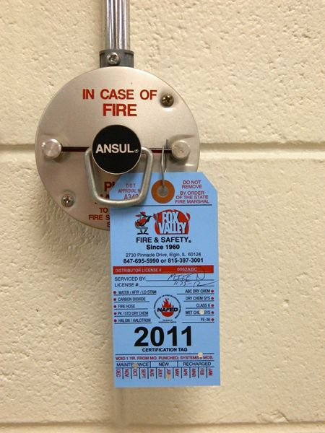

* + - * + 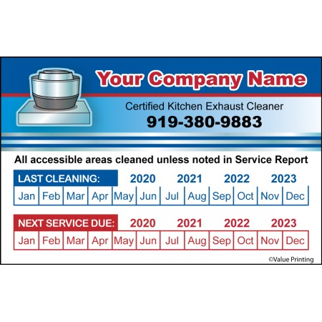Kitchen hoods and suppression systems must be current on 6-month inspections. Tag must be present on pull station.
        + Hoods and ducts must be current on professional cleaning with decal posted clearly on hood.
        + Trucks must be parked

at least 10 feet away

from buildings, vehicles,

and any combustible

materials.

* + - * + Solid fuel burning materials

must not be stored closer than 3 feet to cooking appliance or heat

source (wood, briquettes, etc.)

* In order to operate and conduct business out of a food truck or trailer, you must have Washington State Department of Labor and Industries label on unit per RCW 43.22.340. An inspection will not be completed on food truck without the label and operation will not be permitted.

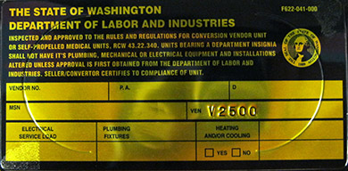

**Reminders**

* + The Fire Inspector has the authority to use discretion in enforcement of these hazards.
  + Under no circumstances shall fire hydrants be blocked or obstructed.
  + Any extension cords or electrical cables in foot traffic areas must be covered by an appropriate and approved protective cover and cannot be in contact with water or other chemicals.
  + Any use of extension cords or power strips MUST be labeled and appropriate for outside use.
  + Smoking within 25 feet of any cooking appliance or combustible material is prohibited.
  + Placement of any tents, vehicles or other temporary structure must not block emergency vehicle access.
  + Full Special Event requirements can be found in YMC 9.70 Special Events - Parades

**City of Yakima Fire Department**

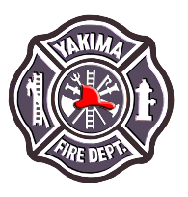Fire and Life Safety Division